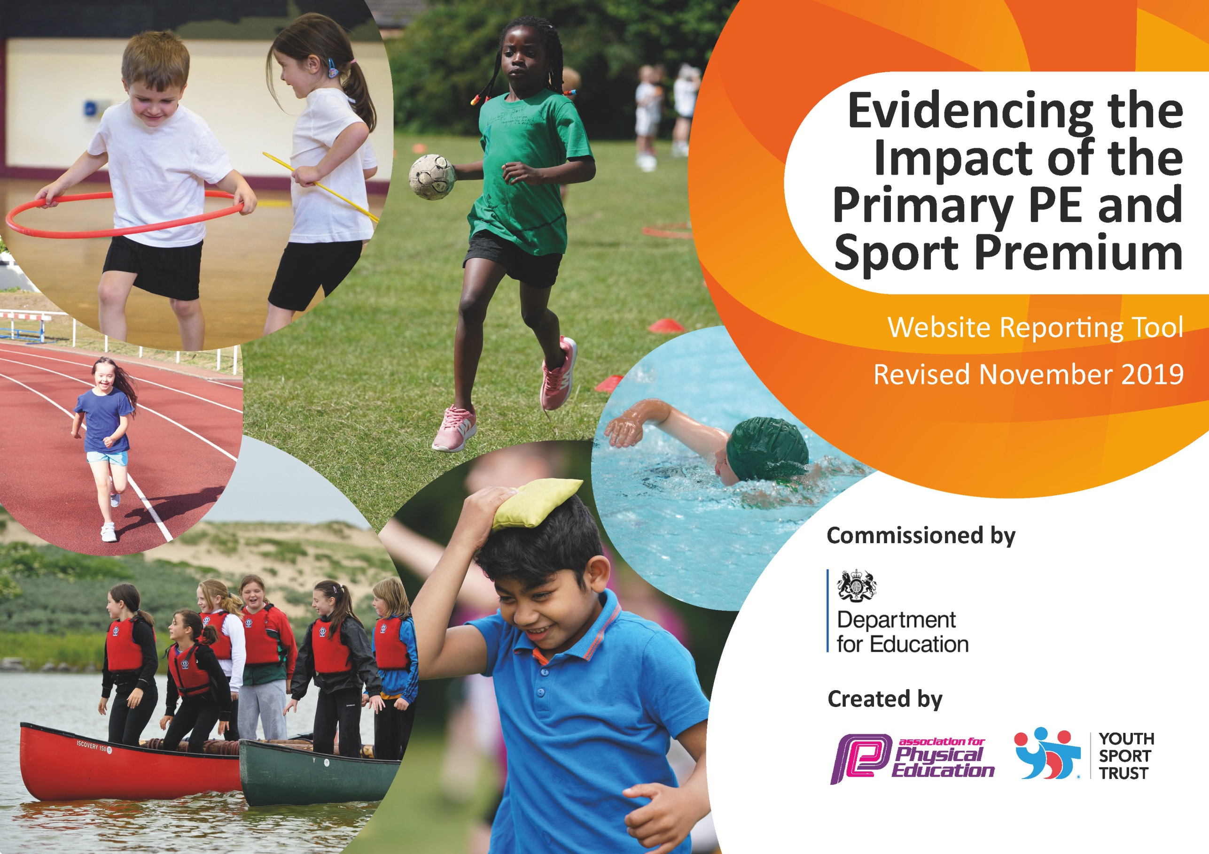
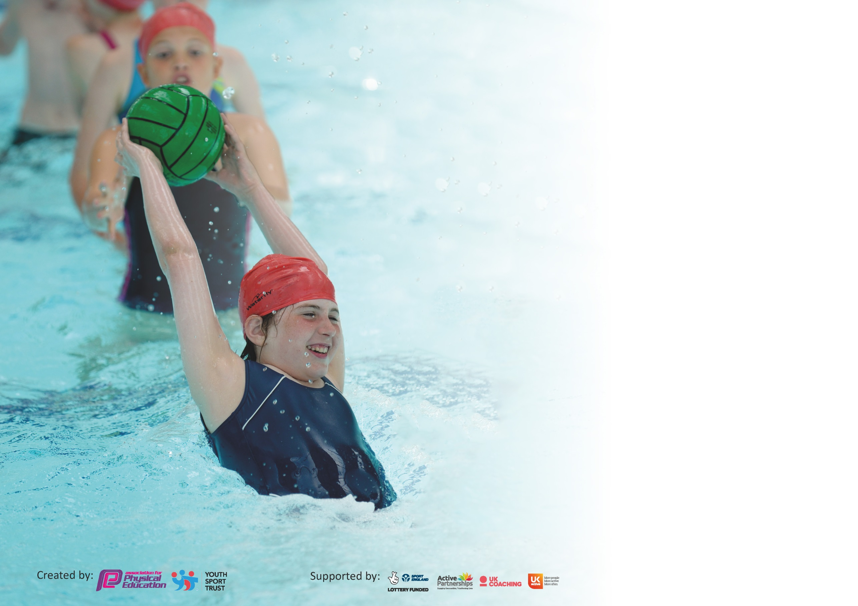

It is important that your grant is used effectively and based on school need. The Education Inspection Framework (Ofsted 2019 p64) makes clear there will be a focus on ‘whether leaders and those responsible for governors all understand their respective roles and perform these in a way that enhances the effectiveness of the school’.

Under the Quality of Education criteria (p41) inspectors consider the extent to which schools can articulate their curriculum (INTENT), construct their curriculum (IMPLEMENTATION) and demonstrate the outcomes which result (IMPACT).

To assist schools with common transferable language this template has been developed to utilise the same three headings which should make your plans easily transferable between working documents.

Schools must use the funding to make additional and sustainable improvements to the quality of Physical Education, School Sport and Physical Activity (PESSPA) they offer. This means that you should
use the Primary PE and Sport Premium to:

- Develop or add to the PESSPA activities that your school already offer
- Build capacity and capability within the school to ensure that improvements made now will benefit pupils joining the school in future years

Please visit gov.uk for the revised DfE guidance including the 5 key indicators across which schools should demonstrate an improvement. This document will help you to review your provision and to report your spend. DfE encourages schools to use this template as an effective way of meeting the reporting requirements of the Primary PE and Sport Premium.

We recommend you start by reflecting on the impact of current provision and reviewing the previous spend.

Schools are required to publish details of how they spend this funding as well as on the impact it has on pupils’ PE and sport participation and attainment by the end of the summer term or by 31st July 2020 at the latest.

We recommend regularly updating the table and publishing it on your website throughout the year. This evidences your ongoing self-evaluation of how you are using the funding to secure maximum, sustainable impact. Final copy must be posted on your website by the end of the academic year and no later than the 31st July 2020. To see an example of how to complete the table please click HERE.

Support for review and reflection - considering the 5 key indicators from DfE, what development needs are a priority for your setting and your pupils now and why? Use the space below to reflect on previous spend and key achievements and areas for development.

Key achievements to date until July 2020: | Areas for further improvement and baseline evidence of need:
- 44% of children at St Peters attending after school clubs  - Most year groups taking part in 2 hours of high quality PE per week  - Key improvements in the quality and delivery of swimming curriculum  - Girls active / Active leaders schemes encouraging more children to become active | - Further development of the profile of PE, health and wellbeing at St Peters  - Target less sporty year groups to become more active and involved in lunch time and after school clubs  - Increase participation in intra and inter competitive opportunities  - Target children who have not reached 25m in swimming by the end of year 4 and put intervention in place to achieve by the end of year 6.

Meeting national curriculum requirements for swimming and water safety. (Children at ST Peter’s receive their swimming curriculum in year 4 as of academic year 2018-19)
What percentage of your current Year 6 cohort swim competently, confidently and proficiently over a distance of at least 25 metres?  N.B. Even though your pupils may swim in another year please report on their attainment on leaving  primary school at the end of the summer term 2020. | 75 %
What percentage of your current Year 6 cohort use a range of strokes effectively [for example, front crawl, backstroke and breaststroke]? | 68 %
What percentage of your current Year 6 cohort perform safe self-rescue in different water-based situations? | 45% *  This cohort di not swim after the academic year 2017 – 18 when self-rescue was not part of the swimming curriculum taught. We have reviewed our swimming curriculum from the academic year 2018-19 to ensure that safe self-rescue is now taught as part of the scheme of work. Therefore impact will not show until data for year 4 swimmers from 2018 – 19 is published as these children will then be in year 6.
Schools can choose to use the Primary PE and Sport Premium to provide additional provision for swimming but this must be for activity over and above the national curriculum requirements. Have you used it in this way? | Not for this cohort.

Action Plan and Budget Tracking
Capture your intended annual spend against the 5 key indicators. Clarify the success criteria and evidence of impact that you intend to measure to evaluate for pupils today and for the future.

Academic Year: 2019/20 | Total fund allocated: £17,664 | Date Updated: 4.7.20
Key indicator 1: The engagement of all pupils in regular physical activity – Chief Medical Officer guidelines recommend that primary school pupils undertake at least 30 minutes of physical activity a day in school
Intent | Implementation |  | Impact
To ensure all pupils are encouraged to and given the opportunity to take part in at least 30 active minutes per day | 10 minutes active blast (Active 8, go noodle, Joe Wicks etc) | Funding allocated: £0 | Children are ready to learn, energised and core strength and stamina to work is improving | Sustainability and suggested next steps:  Subject leader to monitor 10 mins is being implemented
Active leader (KS2) programme set up and run alongside Girls Active (KS1) | With help of sports apprentice and HASPN to train and monitor children have been trained to run activities at lunchtimes on a rota. All children encouraged to engage | Funding allocated: Part of HASPN package (Total cost £2350) | More children are actively engaged in physical activity each day. Leaders take an active role in leading growing in confidence which has transferred to all areas of learning | Sustainability and suggested next steps:  Year 5 Girls active leaders to become Active leaders in year 6 and help to organise / train new leaders. Year 5 to begin training in Summer term (Covid 19 closures stopped this)
Equipment purchased to allow lunch time activities to be resourced. | Equipment used to run activities and games | Funding allocated: £209. | Smooth running of engaging activities | Sustainability and suggested next steps:  Sports leaders and sports apprentice to ensure equipment is maintained and lasts.
Key indicator 2: The profile of PESSPA being raised across the school as a tool for whole school improvement
Intent | Implementation |  | Impact
To develop quality teaching of PE lessons across the school | CPD for all staff to watch and learn from a qualified sports coach / PE co-ordinator. | Funding allocated: Part of Premier Sport professional services (£11,515 total cost for year) | Pupils now receive at least 2 hours of high quality PE per week and are achieving national curriculum outcomes. | Sustainability and suggested next steps:  PE coordinator to monitor and evaluate teaching through learning walks and observations. Staff survey to identify future CPD
To increase participation in extra-curricular sport and competition | Employment of Sports coaching company to deliver extra-curricular sports clubs along-side sports apprentice.  Subscription to HASPN school games and completion programme,  Regular reporting of competitions and results on class dojo, school website and in school assemblies. | Funding allocated:  Part of HASPN package (Total cost £2350) | 85 children from across the school attended extra-curricular clubs in the Autumn term.  Success in a range of competitions in KS2 including cross country, basketball and dodgeball.  Further comps were planned for Spring 2 and Summer terms but did not take place due to school closure. | Sustainability and suggested next steps  Premier sport increased prices over the year meaning they were not cost effective to continue with in 2020-21. Sports apprentice has been trained to continue provision as employment will continue into 2020-21.  Continue to offer a wide range of extra-curricular sports clubs. Increase offer for more clubs for KS1.  Target for 50% of school to be involved in extra sport by Summer 2021.

Key indicator 3: Increased confidence, knowledge and skills of all staff in teaching PE and sport
Intent | Implementation |  |  | Impact
To ensure 2 hours of high quality PE is delivered across the school.  To improve the swimming curriculum taught to year 4 | CPD for all staff to watch and learn from a qualified sports coach / PE co-ordinator.  New swimming lead appointed who completed ASA level 2 training. Review of curriculum and how it is structured undertaken by PE lead and Swimming lead. Support staff also completed ASA approved training to improve quality of teaching. | Funding allocated: Part of Premier Sport professional services (£11,515 total cost for year)  Part of HASPN package (Total cost £2350) + £30 for swim charter. |  | Pupils now receive at least 2 hours of high quality PE per week and are achieving national curriculum outcomes.  Year 4 children now receive high quality progressive swimming curriculum. | Sustainability and suggested next steps:  PE coordinator to monitor and evaluate teaching through learning walks and observations. Staff survey to identify future CPD  Programme to be rolled out again next year. Any children who don’t progress to achieving 25m by the end of the programme, will be picked up and given extra intervention sessions in year 5/ 6
Key indicator 4: Broader experience of a range of sports and activities offered to all pupils
Intent | Implementation |  |  | Impact
To increase the range of sports and activities on offer at after school clubs and lunchtimes | Employment of Sports coaching company to deliver extra-curricular sports clubs along-side sports apprentice.  Subscription to HASPN school games and completion programme.  Skipping workshop with Skip England attended  Regular reporting of competitions and results on class dojo, school website and in school assemblies. |  | Funding allocated: Part of Premier Sport professional services (£11,515 total cost for year)  Part of HASPN package (Total cost £2350) | 85 children from across the school attended extra-curricular clubs in the Autumn term. These included fencing, boxercise, archery and cheerleading.  Success in a range of competitions in KS2 including cross country, basketball and dodgeball.  Further comps were planned for Spring 2 and Summer terms but did not take place due to school closure. | Sustainability and suggested next steps:  Premier sport increased prices over the year meaning they were not cost effective to continue with in 2020-21. Sports apprentice has been trained to continue provision as employment will continue into 2020-21. Extra-curricular clubs will be linked to competition calendar.  Continue to offer a wide range of extra-curricular sports clubs. Increase offer for more clubs for KS1.  Target for 50% of school to be involved in extra sport by Summer 2021.
Additional achievements:
Year 5/6 Basketball team qualified for level 2 finals
Year 3/4 Dodgeball A team winners, B team 2nd place.
Year 5/6 Dodgeball A team level 2 final qualifiers
Year 5/6 football team 4th place in Hinckley and Bosworth tournament
28 children attended the Hinckley and Bosworth Cross Country races in the Spring term.
4 children qualified to represent Hinckley and Bosworth in the Cross Country County finals

Planned competitions for Spring 2 and Summer Term that did not take place due to Covid 19 lockdown
- Swimming gala
- Quad kids
- Tag Rugby
- Area Athletics
- Year 5/6 cricket
- KS1 Multisports
- KS1 football.
- School sports day

Key indicator 5: Increased participation in competitive sport
Intent | Implementation |  | Impact
To increase opportunities for competitive sport | Up until school closure due to Covid 19;  Subscription to HASPN school games and completion programme.  Arrangement and participation in a range of competitions arranged on a local level independent of HASPN  Regular reporting of competitions and results on class dojo, school website and in school assemblies.  Planned competitions to be implemented by sports apprentice with local primary school (Tag rugby / football) | Funding allocated: | Success in a range of competitions in KS2 including cross country, basketball and dodgeball.  Further comps were planned for Spring 2 and Summer terms but did not take place due to school closure.  Awareness amongst children of competitions and sporting achievements across the school has increased. More children now aspire to take part and compete. | Sustainability and suggested next steps:  Premier sport increased prices over the year meaning they were not cost effective to continue with in 2020-21. Sports apprentice has been trained to continue extra-curricular provision as employment will continue into 2020-21. Clubs will be linked to up and coming competitions.  Continue to offer a wide range of extra-curricular sports clubs. Increase offer for more clubs for KS1 linked to competition ops.  Volunteer St Peters as a venue to organise KS1 comps and increase ops.

ADDITIONAL NOTE: The £2350 paid to Hinckley and Bosworth HASPN has not been fully utilised due to school closures in March 2020. This money was paid out at the beginning of the academic year 2019-20 to enable schools to access in school development programs for staff and children along with competition provision that did not take place. At the time of writing this report, no refund has been offered for the services we did not receive which should be taken into account when looking at our total spend for the year.

