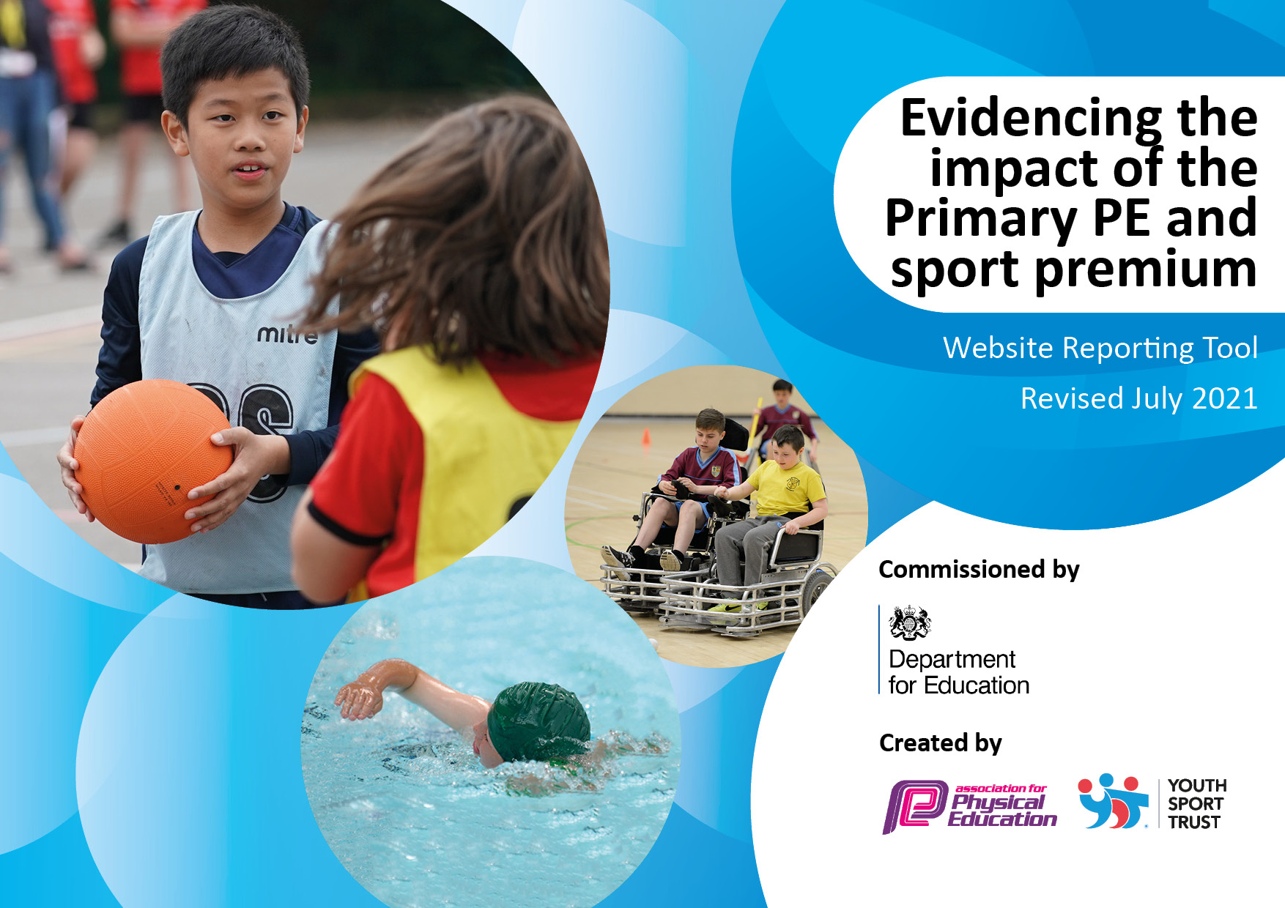
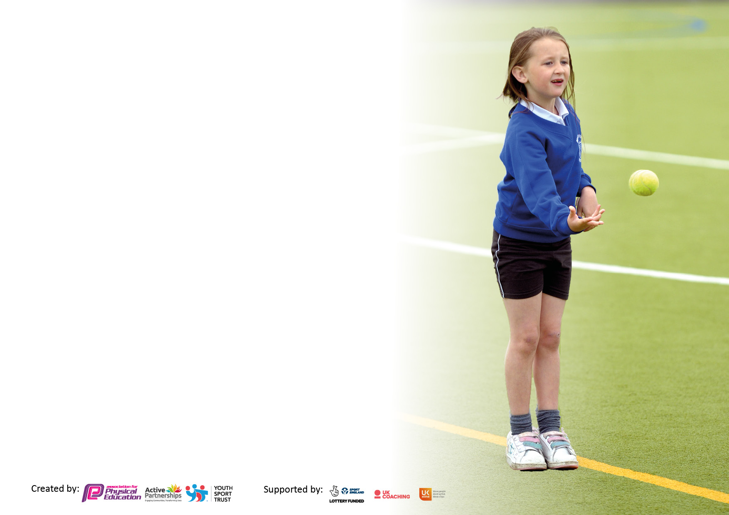

It is important that your grant is used effectively and based on school need. The Education Inspection Framework makes clear there will be a focus on ‘whether leaders and those responsible for governors all understand their respective roles and perform these in a way that enhances the effectiveness of the school’.

Under the Quality of Education Ofsted inspectors consider:
Intent - Curriculum design, coverage and appropriateness
Implementation - Curriculum delivery, Teaching (pedagogy) and Assessment
Impact - Attainment and progress

To assist schools with common transferable language this template has been developed to utilise the same three headings which should make your plans easily transferable between working documents.

Schools must use the funding to make additional and sustainable improvements to the quality of Physical Education, School Sport and Physical Activity (PESSPA) they offer. This means that you should use the Primary PE and sport premium to:

- Develop or add to the PESSPA activities that your school already offer
- Build capacity and capability within the school to ensure that improvements made now will benefit pupils joining the school in future years
- The Primary PE and sport premium should not be used to fund capital spend projects; the school’s budget should fund these.

Pleasevisitgov.ukfortherevisedDfEguidanceincludingthe5keyindicatorsacrosswhichschoolsshoulddemonstrate animprovement.Thisdocumentwillhelpyoutoreviewyourprovisionandtoreportyourspend.DfEencouragesschools to use this template as an effective way of meeting the reporting requirements of the Primary PE and sport premium.

We recommend you start by reflecting on the impact of current provision and reviewing the previous spend.

Schools are required to publish details of how they spend this funding, including any under-spend from 2019/2020, as well as on the impact it has on pupils’ PE and sport participation and attainment. All funding must be spent by 31st July 2022.

We recommend regularly updating the table and publishing it on your website throughout the year. This evidences your ongoing self-evaluation of how you are using the funding to secure maximum, sustainable impact. Final copy must be posted on your website by the end of the academic year and no later than the 31st July 2021. To see an example of how to complete the table please click HERE.

Details with regard to funding
Please complete the table below.

Total amount carried over from 2019/20 | £ 0
Total amount allocated for 2020/21 | £ 17,800
How much (if any) do you intend to carry over from this total fund into 2021/22? | £10,178.99
Total amount allocated for 2021/22 | £ TBC
Total amount of funding for 2021/22. To be spent and reported on by 31st July 2022. | £ TBC
Swimming Data
Please report on your Swimming Data below.

Meeting national curriculum requirements for swimming and water safety.

N.B. Complete this section to your best ability. For example you might have practised safe self-rescue techniques on dry land which you can then transfer to the pool when school swimming restarts.
Due to exceptional circumstances priority should be given to ensuring that pupils can perform safe self rescue even if they do not fully meet the first two requirements of the NC programme of study
What percentage of your current Year 6 cohort swim competently, confidently and proficiently over a distance of at least 25 metres?  N.B. Even though your pupils may swim in another year please report on their attainment on leaving primary school at the end of the summer term 2020.  Please see note above | 87%
What percentage of your current Year 6 cohort use a range of strokes effectively [for example, front crawl, backstroke and breaststroke]?  Please see note above | 65%
What percentage of your current Year 6 cohort perform safe self-rescue in different water-based situations? | 87%
Schools can choose to use the Primary PE and sport premium to provide additional provision for swimming but this must be for activity over and above the national curriculum requirements. Have you used it in this way? | No due to pool closure due to covid 19 restrictions

Action Plan and Budget Tracking
Capture your intended annual spend against the 5 key indicators. Clarify the success criteria and evidence of impact that you intend to measure to evaluate for pupils today and for the future.

Academic Year: 2020/21 | Total fund allocated: | Date Updated:
Key indicator 1: The engagement of all pupils in regular physical activity – Chief Medical Officers guidelines recommend that primary school pupils undertake at least 30 minutes of physical activity a day in school
Intent | Implementation |  | Impact
To ensure all pupils are encouraged to and given the opportunity to take part in at least 30 active minutes per day | 10 minutes active blast (Active 8, go noodle, Joe Wicks etc) Due to covid 19 class bubble situation, weekly KS1 and KS2 class challenges set and practiced daily | Funding allocated: £0 | Children are ready to learn, energised and core strength and stamina to work is improving | Sustainability and suggested next steps:  Subject leader to monitor 10 mins is being implemented –(Not possible due to covid 19 restrictions) Weekly class scores collected both as a class and individually. Reported back to children and parents to motivate and celebrate.  Next steps: to continue class challenges to be child led by sports leaders next academic year.
To ensure all children are as active as possible during reduced lunchtimes in limited space due to Covid 19 class bubbles | Lunchtime staff provided with a bank of playground games to refer to end encourage children to engage in more purposeful play.  Lunchtime play equipment ordered for each class to enhance the above | Funding allocated: £ 784.80 | Less behavioural incidents at play time, children more active and involved in purposeful play. | Sustainability and next steps:  Sports Coach to monitor behaviour and continue to develop game play encouraging children to become increasingly independent.  Class monitors and sports apprentice to ensure equipment is maintained and lasts.  Next steps: train sports leaders to lead activities using new equipment purchased when bubbles are no longer used.
To increase active minutes during the school day | Mesh installed on school field to allow children to complete “The Daily Lap” each day | Funding allocated:  £3917.16 | Daily lap to be fully implemented during 2021-22.  Classes will complete as many laps as possible during the week – award given to the class with the most laps in achievement assembly at the end of each monthly. | Sustainability and next steps:  Ensure all children are using track across the school through class recording charts and rewards for most laps completed for KS1 and 2 monthly in assemblies.  Next steps: To extend the daily lap to the daily km (5 times round the field). Awards given to those who engage. Parents invited to do a lap/s at the beginning and end of the school day.
Key indicator 2: The profile of PESSPA being raised across the school as a tool for whole school improvement
Intent | Implementation |  | Impact
To develop quality teaching of PE lessons across the school | CPD for all staff to watch and learn from a qualified sports coach / PE co-ordinator – not possible due to covid 19 regulations  Subject leader to develop long and medium- term planning to ensure teachers are teaching 2 lessons per week and are clear about what to teach when and how to assess (Virtual instruction given) | Funding allocated: £0  Completed in directed time. | Pupils now receive at least 2 hours of high-quality PE per week and are achieving national curriculum outcomes which are assessed using key tasks and curriculum linked expectations. | Sustainability and suggested next steps:  PE coordinator to monitor and evaluate teaching through learning walks and observations. Staff survey to identify future CPD. Pupil interviews conducted half termly to measure success.
To increase participation in extra-curricular sport and competition | Not possible due to covid 19 restrictions meaning all extra-curricular competitions were cancelled.  Extra-curricular class bubble multi-sports clubs were held after school. | Funding allocated:  Sports coach after school wage: £1,475.76  HABSSA membership to come out of 21-22 funding allocation. | Children engaged in after school clubs - limited engagement from years 5/6.  No competitions held outside of school.  Hinckley and Bosworth in house Quad kids comp held for KS2 in July. Several children achieved area awards particularly in year 4 where there is considerable talent. | Sustainability and suggested next steps  Sports coach to continue employment for 2021-22  Offer a wider range of sports specific extra-curricular sports clubs to engage upper KS2.Increase offer for more clubs for KS1.  Enrolment in HABSSA activity network for 2021 – 22 to take part ion a more comprehensive competition calendar.  Target for 40% of school to be involved in extra sport by Summer 2022.
To increase whole school awareness of how physical activity can improve standards across the curriculum through its physical, health and wellbeing benefits | Mesh installed on school field to allow children to complete “The Daily Lap” each day.  Staff training provided to highlight the benefits of using this technique (supported by daily mile website). Resources and ideas of how to implement provided so it has maximum impact for the children but minimum impact of teacher workload or curriculum delivery. | Funding allocated:  £3917.16 | Daily lap to be fully implemented during 2021-22.  Classes will complete as many laps as possible during the week – award given to the class with the most laps in achievement assembly at the end of each monthly. | Sustainability and next steps:  Ensure all children are using track across the school through class recording charts and rewards for most laps completed for KS1 and 2 monthly in assemblies.  Next steps: To extend the daily lap to the daily km (5 times round the field). Awards given to those who engage. Parents invited to do a lap/s at the beginning and end of the school day

Key indicator 3: Increased confidence, knowledge and skills of all staff in teaching PE and sport
Intent | Implementation |  | Impact
To ensure 2 hours of high-quality PE is delivered across the school.  To improve the swimming curriculum taught to year 4 | CPD for all staff to watch and learn from a qualified sports coach / PE co-ordinator - not possible due to covid 19 regulations  Subject leader to develop long and medium-term planning to ensure teachers are teaching 2 lessons per week and are clear about what to teach when and how to assess (Virtual instruction given)  Review of curriculum and how it is structured undertaken by PE lead and Swimming lead. New scheme of work written by PE lead to break down skills needed to be taught to non-specialist teachers | Funding allocated: £0  Completed in directed time.  Funding Allocated: £0 | Pupils now receive at least 2 hours of high- quality PE per week and are achieving national curriculum outcomes which are assessed using key tasks and curriculum linked expectations.  Year 4 children now receive high quality progressive swimming curriculum. Not completed due to pool closure and Covid 19 restrictions | Sustainability and suggested next steps:  PE coordinator to monitor and evaluate teaching through learning walks and observations. Staff survey to identify future CPD. Pupil interviews half termly to assess impact of lessons and level of learning.  Programme to be rolled out again next year. Children from current year 4 who cannot swim 25m will be targeted and attend sessions along- side the current year 3 during 2021 - 22
To improve resourcing and delivery of PE curriculum | Resources needed to teach the PE curriculum across the school analysed and purchase and updating of new equipment undertaken. | Funding Allocated: £1063.29 | Curriculum now resources effectively to allow high quality lessons to be taught using the new curriculum planning from the start of academic year 21-22. | Sustainability and suggested next steps:  Ne equipment to be monitored and updated / replaced as necessary. Staff to inform PE lead of any additional equipment needs as they arise.
Key indicator 4: Broader experience of a range of sports and activities offered to all pupils
Intent | Implementation |  | Impact
To increase the range of sports and activities on offer at after school clubs and lunchtimes | Regular reporting of competitions and results on class dojo, school website and in school assemblies.  Not possible due to Covid 19 restrictions. Class weekly challenges carried out and reported along with in house Quad kids comp | Funding allocated: £0 | No competitions carried out during Autumn and Spring terms.  Weekly class scores collected both as a class and individually. Reported back to children and parents to motivate and celebrate.  Hinckley and Bosworth in house Quad kids comp held for KS2 in July. Several children achieved area awards particularly in year 4 where there is considerable talent | Sustainability and suggested next steps:  Sports coach to continue employment for 2021-22  Offer a wider range of sports specific extra-curricular sports clubs to engage upper KS2.Increase offer for more clubs for KS1.  Target for 50% of school to be involved in extra sport by Summer 2022.
To enable all children in EYFS to obtain the skills to ride a two wheeled bike. | “Mini Bikers” to do a weeks intensive teaching with all EYFS children (session each day) enabling the children to acquire the skills to enable them to ride but the end of the week. | Funding allocated:  £380.00 | All children in EYFS able to ride a two wheel balance bike or pedal bike at the conclusion of the sessions. | Sustainability and next steps:  Children encouraged to continue riding at home. School balance bikes used as part of curriculum time when in school.

Key indicator 5: Increased participation in competitive sport
Intent | Implementation |  | Impact
 |  | Funding |  | Sustainability and suggested
To increase opportunities for competitive sport | Not possible due to covid 19 pandemic  Weekly class scores collected both as a class and individually. Reported back to children and parents to motivate and celebrate.  Hinckley and Bosworth in house Quad kids comp held for KS2 in July. | allocated: £0 | Limited due to covid 19 pandemic  Several children achieved area awards particularly in year 4 where there is considerable talent to be developed. | next steps: Buy in to HABSSPN for academic year 2021-22 to provide organisation and opportunity for increased participation in competitions.

Signed off by
Head Teacher: | Helen White
Date: | 6.7.21
Subject Leader: | Katie Fincham
Date: | 6.7.21
Governor:
Date:

