St. Peter’s RC Primary School Knowledge Organiser
Year 2 – Lady Jane Grey

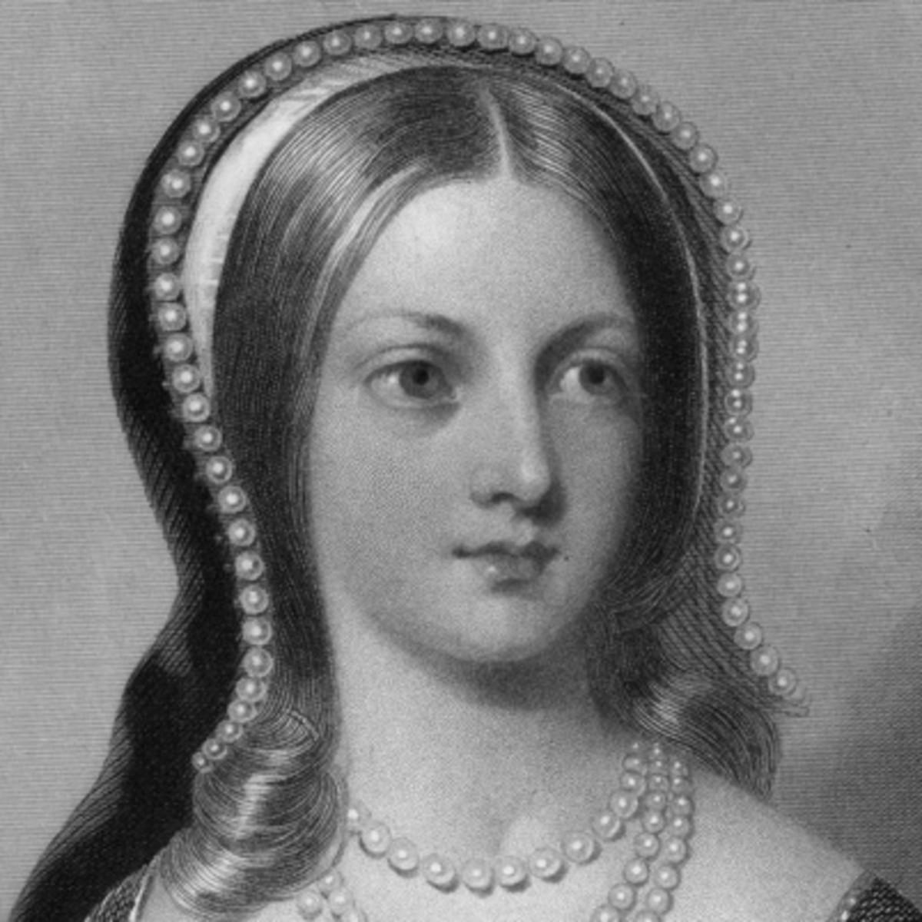
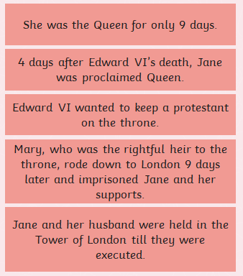
Key Vocabulary | Definition
Queen | Someone who rules the country.
Edward V1 | The king before Lady Jane Grey.
Mary 1 | The queen who had Lady Jane Grey beheaded.
Tudor | The name of a family who ruled England between 1485 and 1603.
Sources | Objects that can tell us information about the past.
Successor | The person who takes over from being king or queen.
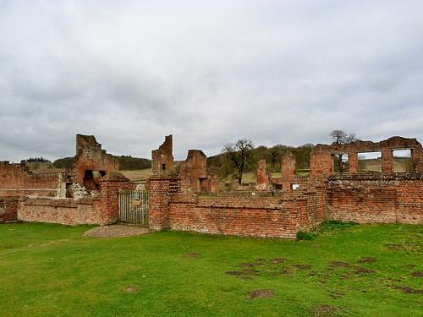

Bradgate Park was Lady Jane Grey’s home when she was a child.

