St. Peter’s RC Primary School Knowledge Organiser
Year 2 – Travel & Transport
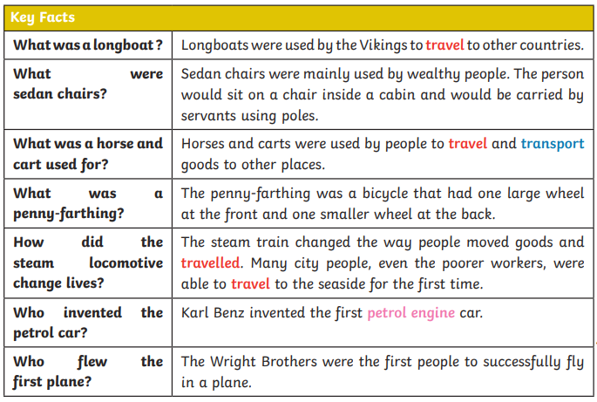
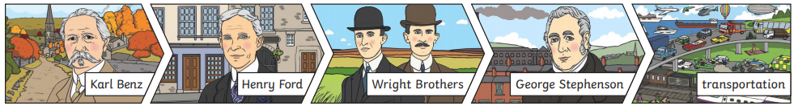
Key Vocabulary | Definition
Travel | Moving from one place to another.
Transport | Moving people or goods from one place to another.
Steam Engine | A steam engine uses steam from boiling water to help it move. The steam pushes the moving parts.
Petrol/combustion engine | Combustion means burning. A petrol engine burns petrol to make it move.
Electric cars | Electric cars use electricity to make the motor turn.
Sources | Objects that tell us about the past.
