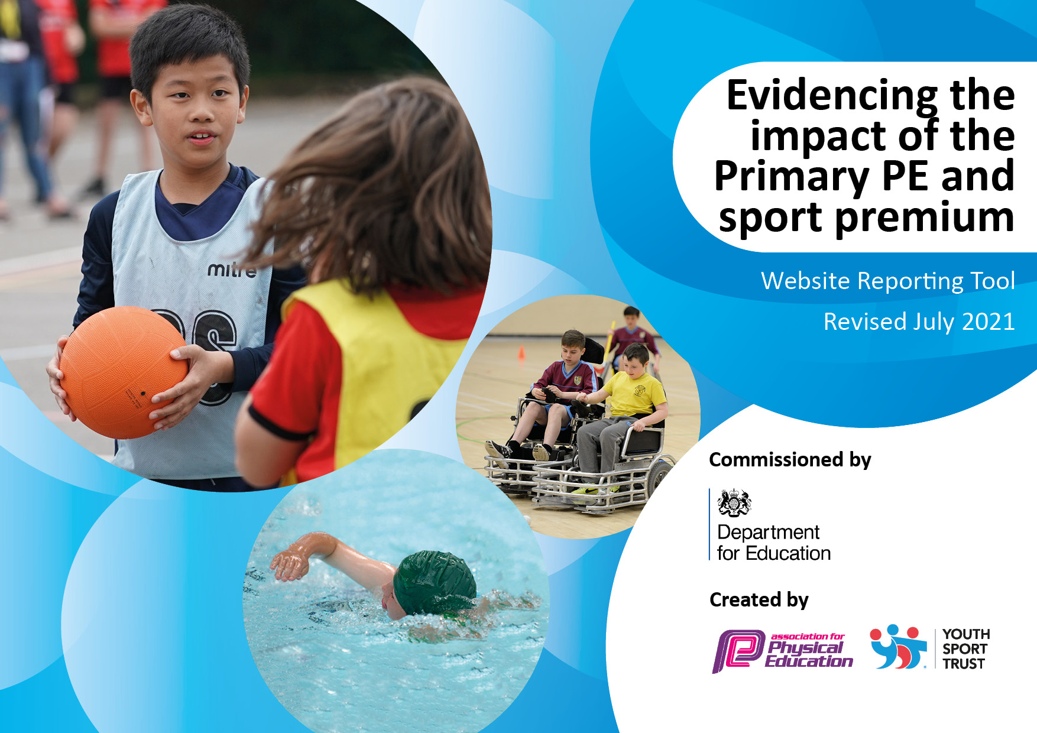
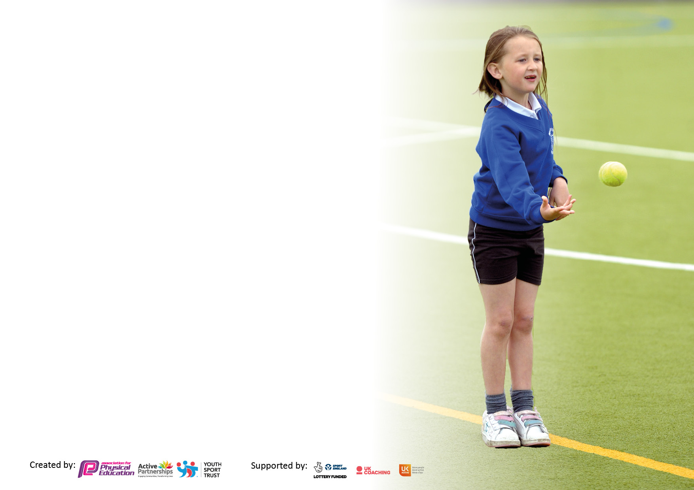

It is important that your grant is used effectively and based on school need. The Education Inspection Framework makes clear there will be a focus on ‘whether leaders and those responsible for governors all understand their respective roles and perform these in a way that enhances the effectiveness of the school’.

Under the Quality of Education Ofsted inspectors consider:
Intent - Curriculum design, coverage and appropriateness
Implementation - Curriculum delivery, Teaching (pedagogy) and Assessment
Impact - Attainment and progress

To assist schools with common transferable language this template has been developed to utilise the same three headings which should make your plans easily transferable between working documents.

Schools must use the funding to make additional and sustainable improvements to the quality of Physical Education, School Sport and Physical Activity (PESSPA) they offer. This means that you should use the Primary PE and sport premium to:

- Develop or add to the PESSPA activities that your school already offer
- Build capacity and capability within the school to ensure that improvements made now will benefit pupils joining the school in future years
- The Primary PE and sport premium should not be used to fund capital spend projects; the school’s budget should fund these.

Pleasevisitgov.ukfortherevisedDfEguidanceincludingthe5keyindicatorsacrosswhichschoolsshoulddemonstrate animprovement.Thisdocumentwillhelpyoutoreviewyourprovisionandtoreportyourspend.DfEencouragesschools to use this template as an effective way of meeting the reporting requirements of the Primary PE and sport premium.

We recommend you start by reflecting on the impact of current provision and reviewing the previous spend.

Schools are required to publish details of how they spend this funding, including any under-spend from 2019/2020, as well as on the impact it has on pupils’ PE and sport participation and attainment. All funding must be spent by 31st July 2022.

We recommend regularly updating the table and publishing it on your website throughout the year. This evidences your ongoing self-evaluation of how you are using the funding to secure maximum, sustainable impact. Final copy must be posted on your website by the end of the academic year and no later than the 31st July 2021. To see an example of how to complete the table please click HERE.

Details with regard to funding
Please complete the table below.

Total amount allocated for 2021/22 | £ 17,760 (£14652.09 spent)
Total amount allocated for 2022/23 | £ 17,760
Total amount of funding for 2022/23. To be spent and reported on by 31st July 2022. | £ TBC
Swimming Data
Please report on your Swimming Data below.

Meeting national curriculum requirements for swimming and water safety.

N.B. Complete this section to your best ability. For example you might have practised safe self-rescue techniques on dry land which you can then transfer to the pool when school swimming restarts.
Due to exceptional circumstances priority should be given to ensuring that pupils can perform safe self rescue even if they do not fully meet the first two requirements of the NC programme of study
What percentage of your current Year 6 cohort swim competently, confidently and proficiently over a distance of at least 25 metres?  N.B. Even though your pupils may swim in another year please report on their attainment on leaving primary school at the end of the summer term 2020.  Please see note above | 42%  (Low figure as programme of study not able to be completed due to covid pandemic – children swim in year 4)
What percentage of your current Year 6 cohort use a range of strokes effectively [for example, front crawl, backstroke and breaststroke]?  Please see note above | 42 %  (Low figure as programme of study not able to be completed due to covid pandemic – children swim in year 4)
What percentage of your current Year 6 cohort perform safe self-rescue in different water-based situations? | 42 %  (Low figure as programme of study not able to be completed due to covid pandemic – children swim in year 4)
Schools can choose to use the Primary PE and sport premium to provide additional provision for swimming but this must be for activity over and above the national curriculum requirements. Have you used it in this way? | No  It was decided to prioritise year 5 and year 4 when we were able to return to swimming.

Action Plan and Budget Tracking
Capture your intended annual spend against the 5 key indicators. Clarify the success criteria and evidence of impact that you intend to measure to evaluate for pupils today and for the future.

Academic Year: 2020/21 | Total fund allocated: | Date Updated:
Key indicator 1: The engagement of all pupils in regular physical activity – Chief Medical Officers guidelines recommend that primary school pupils undertake at least 30 minutes of physical activity a day in school
Intent | Implementation |  | Impact
To ensure all pupils are encouraged to and given the opportunity to take part in at least 30 active minutes per day | Daily lap to be implemented for each class in KS2. KS1 to engage in other activities eg Mouse - a -size  EYFS children all to complete Mini bikers course to enable them to use balance bikes and pedal bike effectively | Funding allocated:  Mini bikers £380 | Children are ready to learn, energised and core strength and stamina to work is improving  All EYFS children are able to ride a two wheel pedal bike in and out of school. | Sustainability and suggested next steps:  Subject leader to monitor effective use of daily lap track. Weekly lap totals collected both as class. Reported back to children and parents in assembly to motivate and celebrate.  EYFS to continue to utilise and make effective use of bikes and trikes  Next steps: to continue to monitor how effectively the track is being used – are children encouraged to push themselves to improve??  To extend the daily lap to the daily km (5 times round the field). Awards given to those who engage. Parents invited to do a lap/s at the beginning and end of the school day.
To ensure all children are as active as possible during lunchtimes | Lunchtime staff provided with a bank of playground games to refer to end encourage children to engage in more purposeful play.  Lunchtime play equipment replenished and ordered for each class to enhance the above  Pirate ship play centre installed to encourage children on engage in imaginative and active play. | Funding allocated: £ 662.95  Pirate ship £4199 | Less behavioural incidents at play time, children more active and involved in purposeful play. | Sustainability and next steps:  Active leaders to monitor behaviour and continue to develop game play encouraging children to become increasingly independent.  Class monitors to ensure equipment is maintained and lasts.  Next steps: train sports new active leaders to lead activities using equipment effectively as sports coach is no longer employed. Children need to take greater responsibility for looking after equipment.
Key indicator 2: The profile of PESSPA being raised across the school as a tool for whole school improvement
Intent | Implementation |  | Impact
To develop quality teaching of PE lessons across the school | CPD for all staff to watch and learn from a PE co-ordinator in staff meetings / training days  Subject leader to develop long and medium- term planning to ensure teachers are teaching 2 lessons per week and are clear about what to teach when and how to assess  Equipment updated and curriculum resourced to enable high quality teaching | Funding allocated: Equipment top ups: £915.51 | Pupils now receive at 2 hours of high-quality PE per week and are achieving national curriculum outcomes which are assessed using key tasks and curriculum linked expectations.  They are enthusiastic about lessons and the high quality equipment available to them. | Sustainability and suggested next steps:  PE coordinator to monitor and evaluate teaching through learning walks and observations. Pupil interviews conducted termly to measure success.  Next steps: Pupil interviews revealed gaps in curriculum as staff not teaching some units. Monitor and put support in place to ensure this doesn’t continue.  Monitor use of equipment and ensure it is stored and maintained effectively.  Purchase new scheme of work to update and resource the curriculum
To increase participation in extra-curricular sport and competition | Participation in HABSSA competitions across Hinckley and Bosworth in a wide range of sports  After School Sports Clubs | Funding allocated:  HABSSA membership: £1120  Sports Coach wage: (Sep – Feb) £461.00  Sports Coaching Company: £850  Coach travel to sports comps: £1050  Teacher Extra Time Cover: £1756  Teacher Extra Time to attend: £1756 | Children engaged in after school clubs - limited engagement from years 6.  Competitions taken part in across KS1 and 2.  Profile of sport raised across the school and benefits to health and wellbeing highlighted and understood. | Sustainability and suggested next steps  Sports company to continue to provide extra curricular sport in order to offer a wider range of sports specific extra-curricular sports clubs to engage more KS1 pupils.  Enrolment in HABSSA activity network for 2022 – 23 to take part in a more comprehensive competition calendar.  Target for 50% of school to be involved in extra sport by Summer 2023
To increase whole school awareness of how physical activity can improve standards across the curriculum through its physical, health and wellbeing benefits | Importance of completing 30 active minutes and ideas of how to implement provided so we can have maximum impact for the children but minimum impact of teacher workload or curriculum delivery.  Ensure use of daily lap track is being fully unutilised. | Funding allocated:  £0 | Daily lap now fully implemented and being used by Year 2 -6 several times daily. | Sustainability and next steps:  Ensure all children are using track across the school effectively  Next steps: To extend the daily lap to the daily km (5 times round the field). Awards given to those who engage. Re introduce reward system for class who complete the most laps as this has lost momentum.

Key indicator 3: Increased confidence, knowledge and skills of all staff in teaching PE and sport
Intent | Implementation |  | Impact
To ensure 2 hours of high-quality PE is delivered across the school.  To improve the swimming curriculum taught to year 4 | CPD for all staff to watch and learn from a qualified sports coach / PE co-ordinator - not possible due to covid 19 regulations  Subject leader to continue development of long and medium-term planning to ensure teachers are teaching 2 lessons per week and are clear about what to teach when and how to assess  Review of curriculum and how it is structured undertaken by PE lead and Swimming lead. New scheme of work written by PE lead to break down skills needed to be taught to non-specialist teachers | Funding allocated: £0  Completed in directed time.  Funding Allocated: £0 | Pupils now receive at least 2 hours of high- quality PE per week and are achieving national curriculum outcomes which are assessed using key tasks and curriculum linked expectations.  Year 4 children now receive high quality progressive swimming curriculum. Not completed due to pool closure and Covid 19 restrictions | Sustainability and suggested next steps:  PE coordinator to monitor and evaluate teaching through learning walks and observations. Staff survey to identify future CPD. Pupil interviews termly to assess impact of lessons and level of learning.  Programme to be rolled out again next year. Children from current year 4 who cannot swim 25m will be targeted and attend sessions along- side the current year 3 during 2022 - 23
To improve provision of Curriculum swimming  To fund catch up swimming sessions for children who missed sessions due to the Covid 19 pandemic  To improve resourcing and delivery of PE curriculum | Swim England qualification for staff to effectively teach groups  Year 5 pupils who are unable to meet curriculum requirements, to attend swimming lessons to catch up from Covid  Resources needed to teach the PE curriculum across the school analysed and purchase and updating of new equipment undertaken. | Funding Allocated: £275  Funding Allocated: £795  Funding Allocated: £1063.29 | High quality swimming lessons delivered leading to higher attainment  Year 5 pupils who could not swim 25m appropriately taken to year 4 swimming sessions  Curriculum now resourced effectively to allow high quality lessons to be taught using the new curriculum planning. | Training and resources were high quality and can be rolled out to others  High percentage of year 4 and 5 pupils able to meet curriculum requirements and exceed them  New equipment to be monitored and updated / replaced as necessary. Staff to inform PE lead of any additional equipment needs as they arise.
Key indicator 4: Broader experience of a range of sports and activities offered to all pupils
Intent | Implementation |  | Impact
To increase the range of sports and activities on offer at after school clubs and lunchtimes | Regular attendance at HABSSA school competitions in a wide range of sports  Reporting of competitions and results on class dojo, school website and in school assemblies.  Varied school sports club programme rolled out to children in KS1 and KS2 | Funding allocated:  HABSSA membership: £1120  Sports Coach wage: (Sep – Feb) £461.00  Sports Coaching Company: £850  Coach travel to sports comps: £1050  Teacher Extra Time Cover: £1756  Teacher Extra Time to attend event: £1756 | Most children in KS2 and KS1 were able to attend sports events including Change for life, basketball and dodgeball. Non sporty and SEND children targeted in several events | Sustainability and suggested next steps:  Sports coach left employment in Feb 22  Offer a wider range of sports specific extra-curricular sports clubs to engage upper KS2.Increase offer for more clubs for KS1 using sports coaching company  Target for 50% of school to be involved in extra sport by Summer 2023
To enable all children in EYFS to obtain the skills to ride a two wheeled bike. | “Mini Bikers” to do a weeks intensive teaching with all EYFS children (session each day) enabling the children to acquire the skills to enable them to ride but the end of the week. | Funding allocated:  £380.00 | All children in EYFS able to ride a two wheel balance bike or pedal bike at the conclusion of the sessions. | Sustainability and next steps:  Children encouraged to continue riding at home. School balance bikes used as part of curriculum time when in school.

Key indicator 5: Increased participation in competitive sport
Intent | Implementation |  | Impact
To increase opportunities for competitive sport | Regular attendance at HABSSA school competitions in a wide range of sports  Reporting of competitions and results on class dojo, school website and in school assemblies.  Varied school sports club programme rolled out to children in KS1 and KS2 | Funding allocated:  HABSSA membership: £1120  Sports Coach wage: (Sep – Feb) £461.00  Sports Coaching Company: £850  Coach travel to sports comps: £1050  Teacher Extra Time Cover: £1756  Teacher Extra Time to attend: £1756 | Most children in KS2 and KS1 were able to attend sports events including Change for life, basketball and dodgeball. Non sporty and SEND children targeted in several events | Sustainability and suggested next steps:  Sports coach left employment in Feb 22  Offer a wider range of sports specific extra-curricular sports clubs to engage upper KS2.Increase offer for more clubs for KS1 using sports coaching company  Target for 50% of school to be involved in extra sport by Summer 2023  New sports kit to be purchased for cross country and athletics events.

Signed off by
Head Teacher: | Helen White
Date: | 9.7.22
Subject Leader: | Katie Fincham
Date: | 9.7.22
Governor:
Date:

